**MIDDLETON CHENEY FOOTBALL CLUB**

**ANNUAL GENERAL MEETING**

**1967**

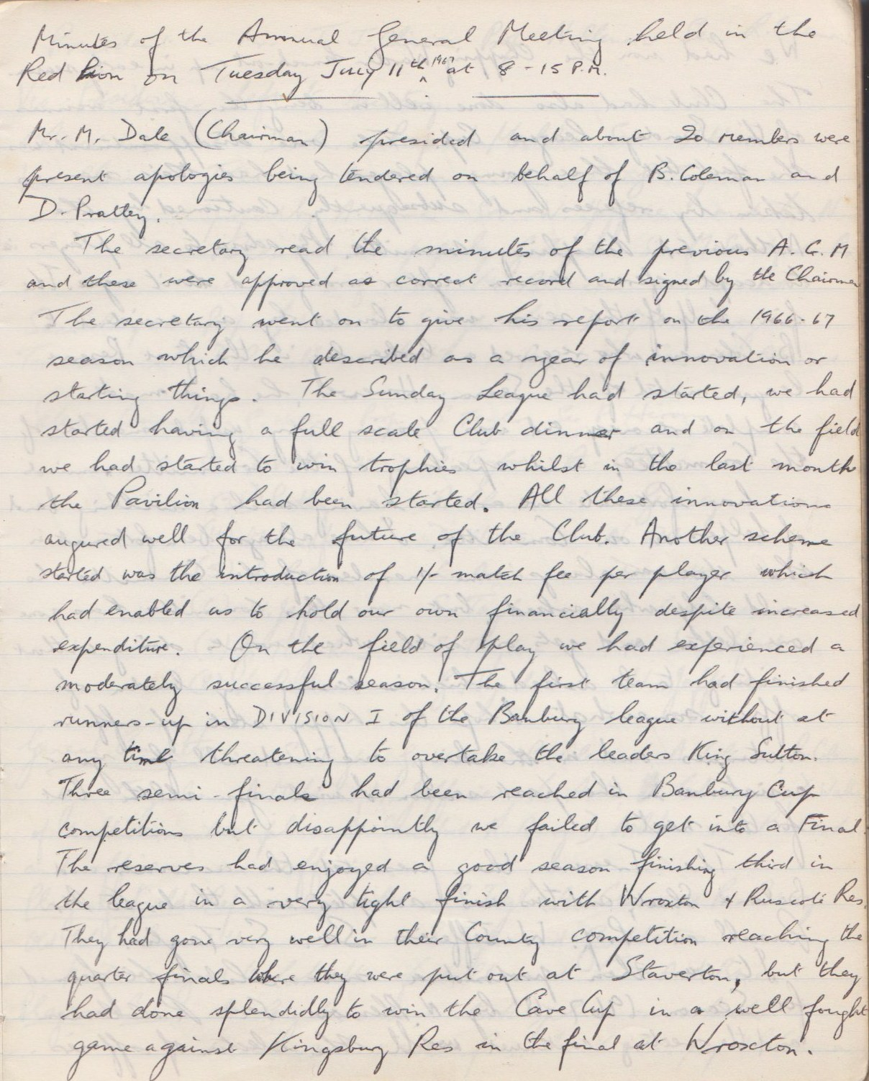

**Continued**

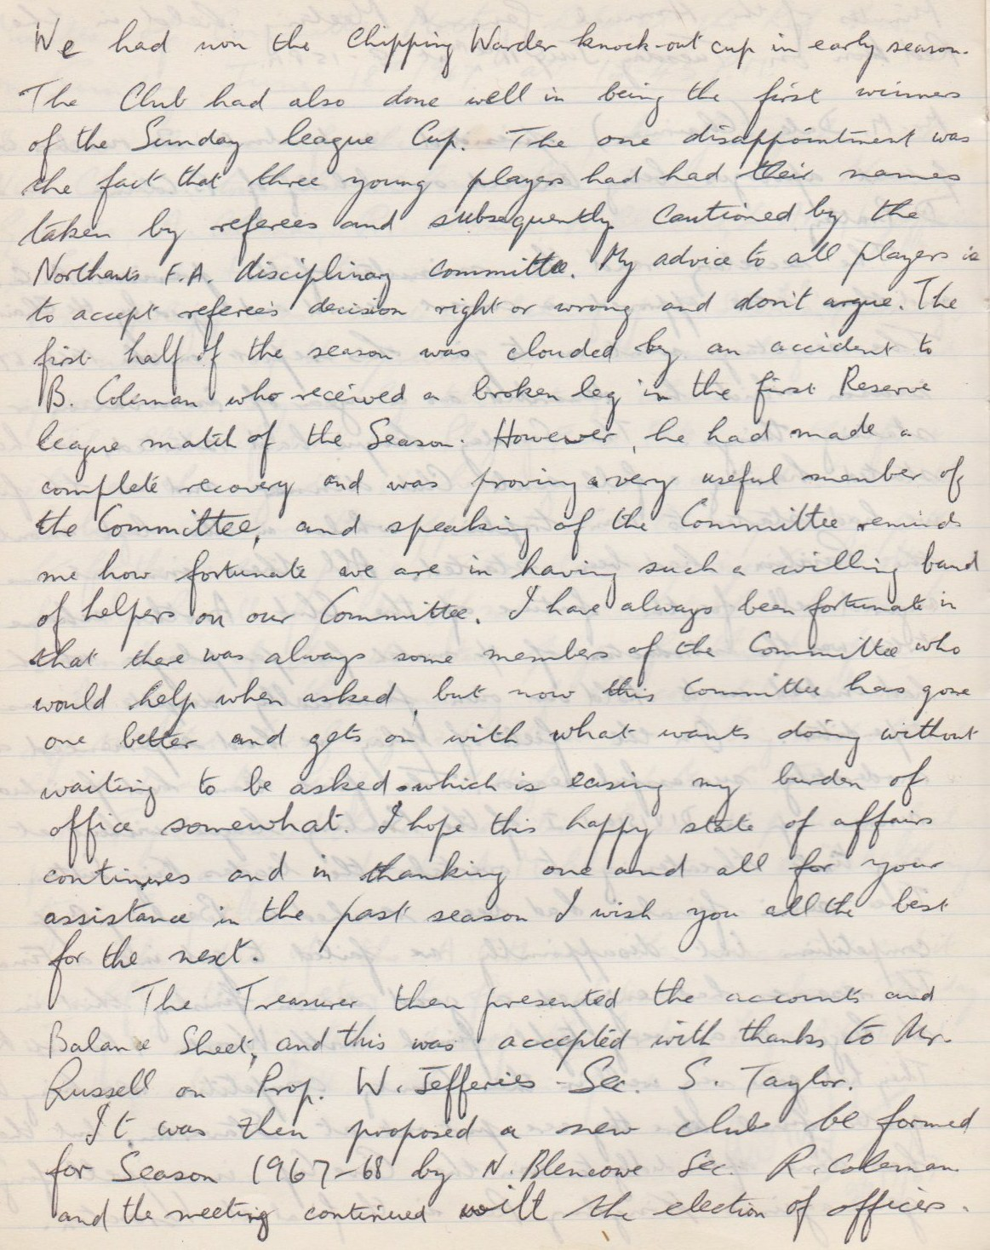

**Continued**

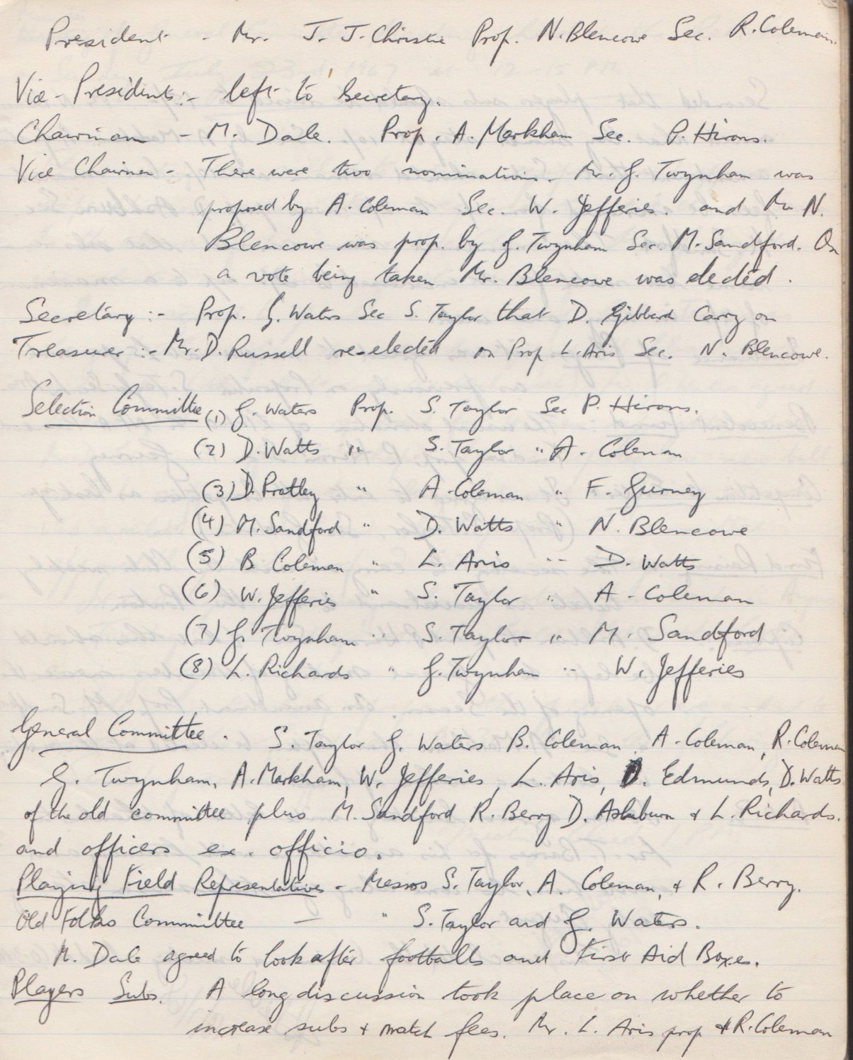

**Continued**

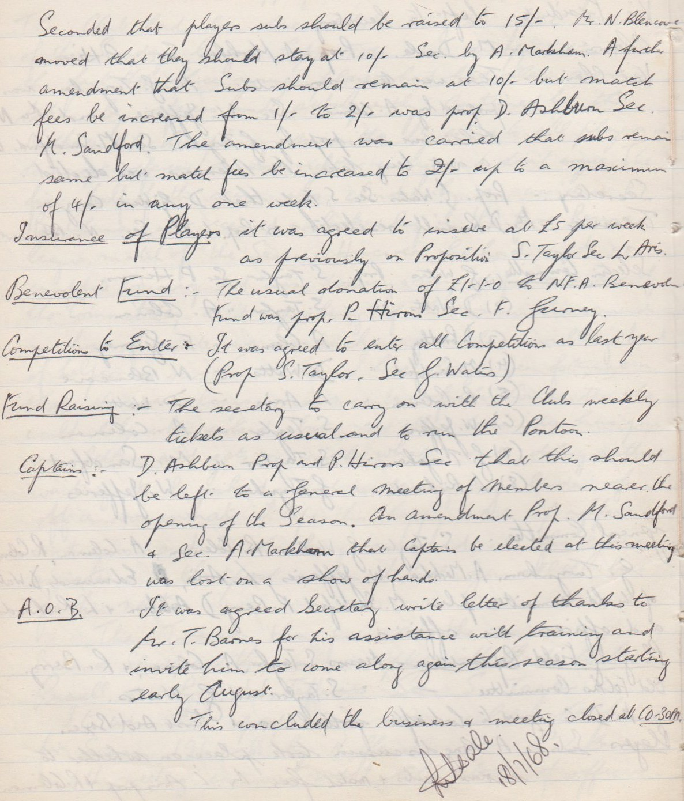

**General Committee Meeting**

**July 23rd 1967**

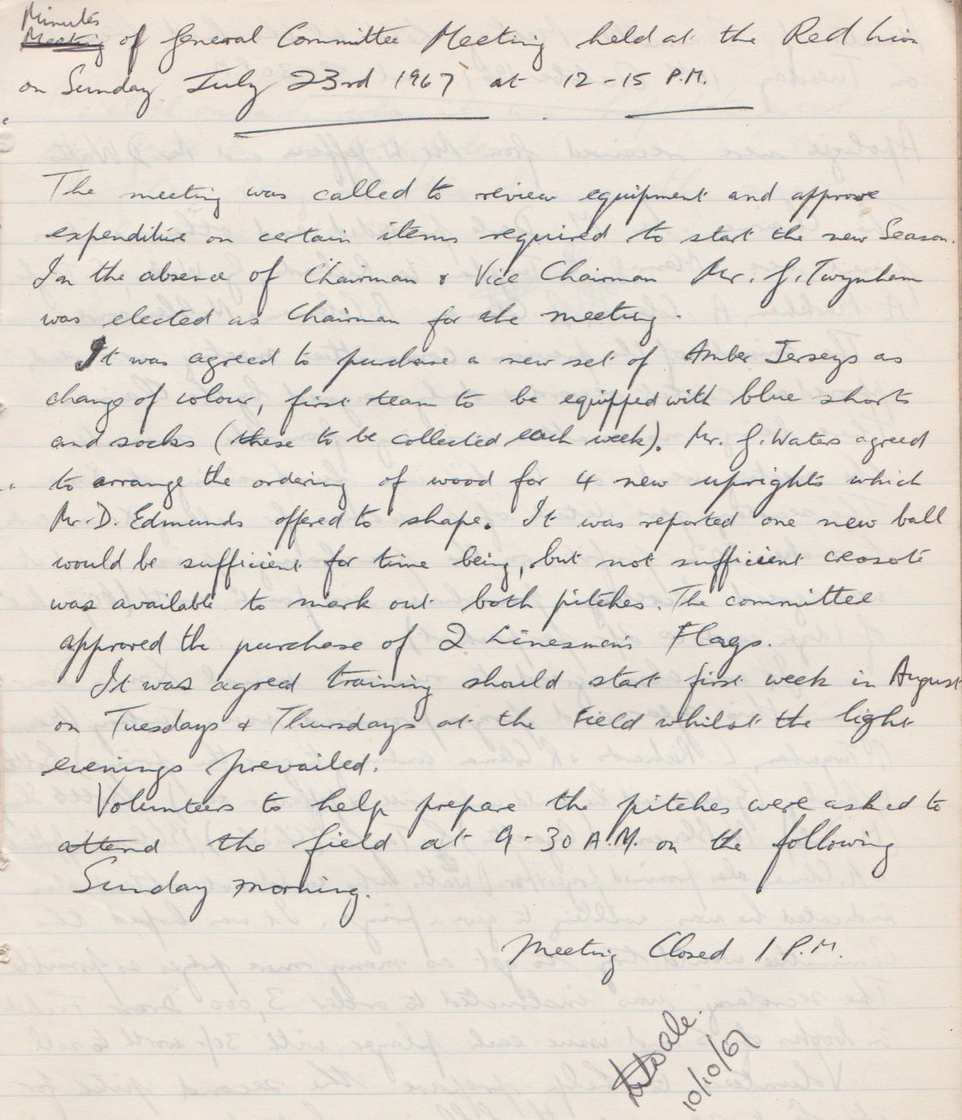

**General Committee Meeting**

**October 10th 1967**

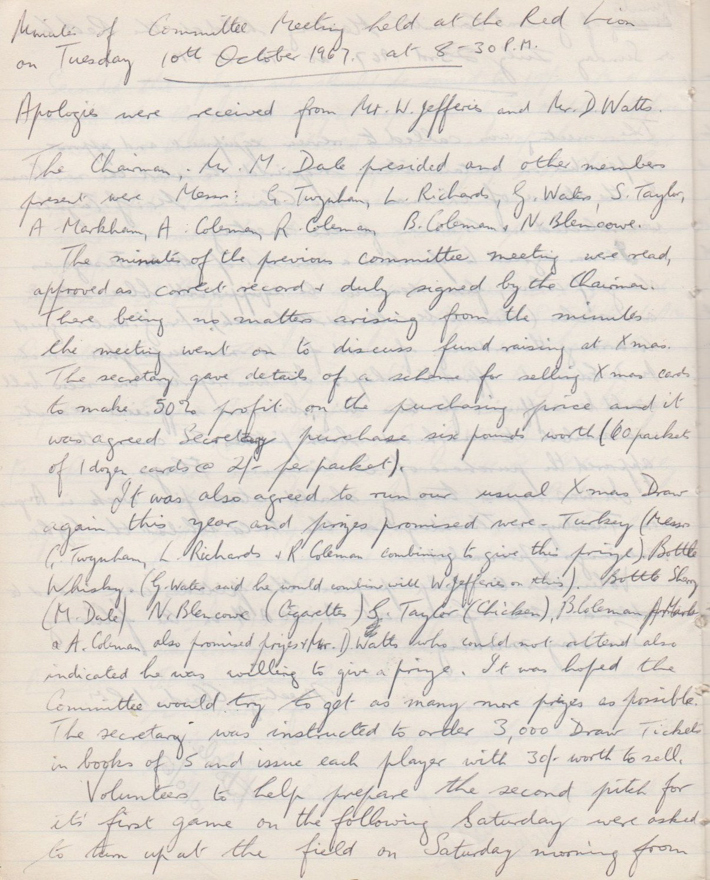

**Continued**

